**SOFT255SL**

**Software Engineering for the Internet using Java**

**Coursework - T1 C1**

**Security Logs System**

**Group No: 31**

N.A.R. Dilshan

G.T.G.L.D. Abedeera

P. A. H. N. Mihiranga

G.T.U. Ariyathilake

B.E.R.R. Jayathilaka

# Table of Content

Table of Content 0

Introduction 1

Analysis 2

Requirements 2

Use Case Diagram 2

ER Diagram 3

Class Diagram 3

Implementation 4

Code 4

GUI 12

Database 14

Conclusion 15

Future Improvements 15

# Introduction

I would like to point out some situations that any of us as students of NSBM University may face in our day today life at NSBM. And also how we deal with those situations.

First one is forgetting to bring your Student ID card. The normal procedure is that the security personnel at the entrance checks your Student ID and lets you in. But if you forgot to bring it, they ask you to write your details in the logbook at the entrance. It could be difficult as well as time wasting task for everyone especially when it is a busy morning at the entrance.

Another situation is you lost something valuable inside the university premises. What we normally do is put a message about the lost item informing others in our WhatsApp chat groups. But the security personnel are the ones who could look out for the lost item and most probably the ones who may find it. But they are not members of your chat group. So they don’t know to whom it belongs to when they found something.

Some of us travel to the university by our own vehicles. But we have no proper parking facility and we have to park our vehicles roadside beside the university without proper security.

Considering situations like that we came up with a better solution to replace the current system. It is to have a security logs program to keep records of some situations like above and also to manage some processes in a better way. Both the security staff and the students could be benefited by this solution. As an example, if the university could arrange a proper space to park the vehicles and assign a security guard to the place, they can easily record the necessary details and manage the car park properly using this program. It is a great relief to the vehicle owners and also the university can charge a parking fee for their trouble since the program records all the necessary details of the vehicles in and out. So the main objective of our Security Logs Program is to manage some day today processes at university in a better way than they are right now and by that, to increase the productivity.

# Analysis

## Requirements

* Functional Requirements
  1. Ability to add records of visitors, parking, lost and found items and people who doesn’t have their University ID.
  2. Ability to view all the records in a detailed form.
  3. Ability to sort and filter records.
  4. Ability to delete mistaken records.
  5. Ability to keep track of time of all entries.
  6. Only the security personal with credentials should be able to login to the system.
* Non-functional Requirements
  1. Security
  2. Simple and Functional GUI
  3. Stability of the software

## Use Case Diagram

## ER Diagram

## Class Diagram

# Implementation

## Code

In here we have used coding concepts like encapsulation, inheritance, exception handling to build our program. We have used a tabbed pane and buttons linked to tabs for easy transition between the sections of the software.

**Admin**

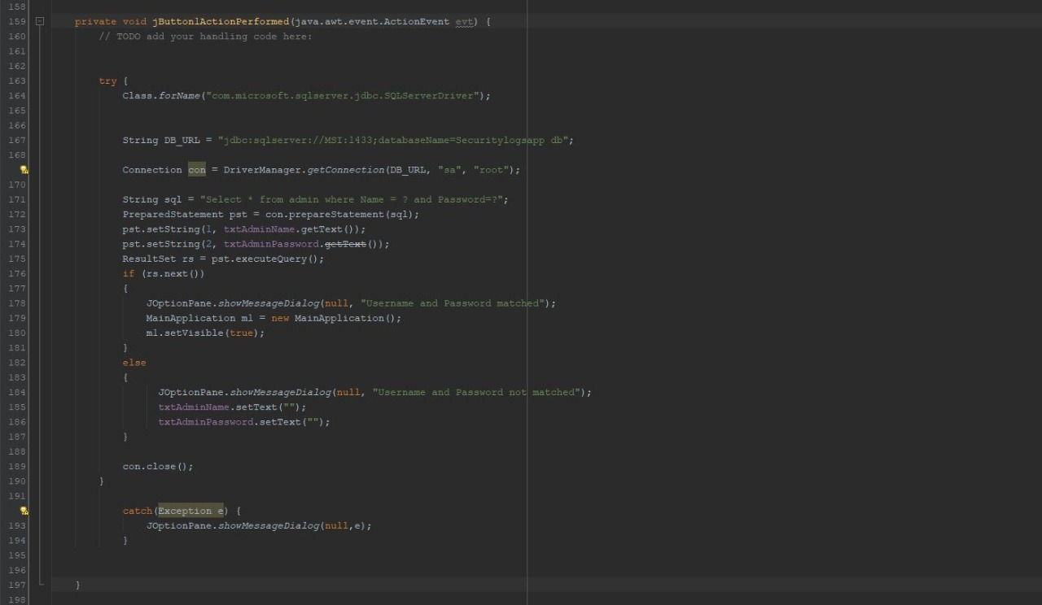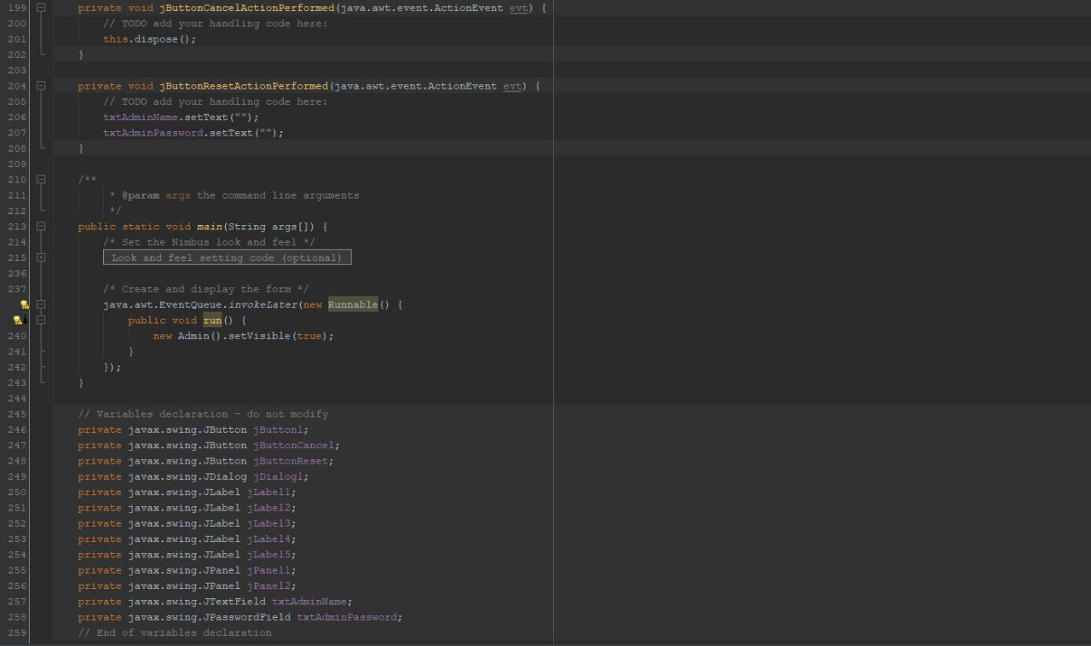

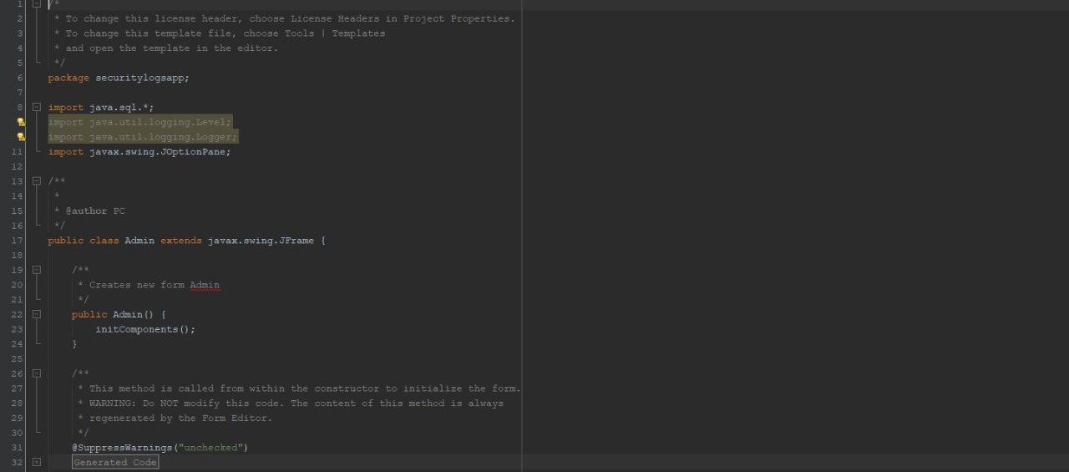

**Main Application**

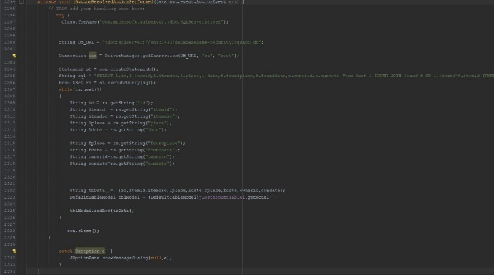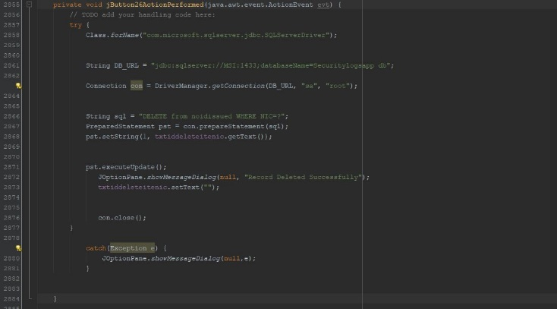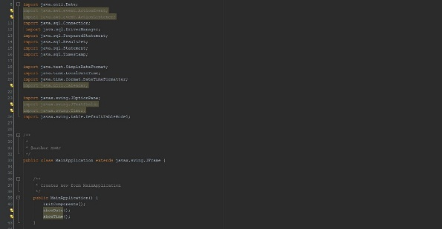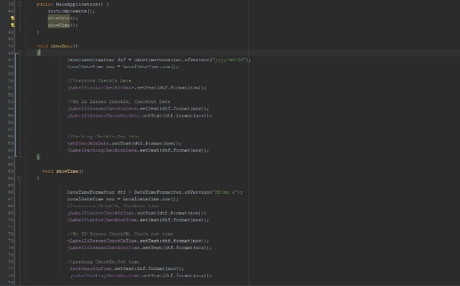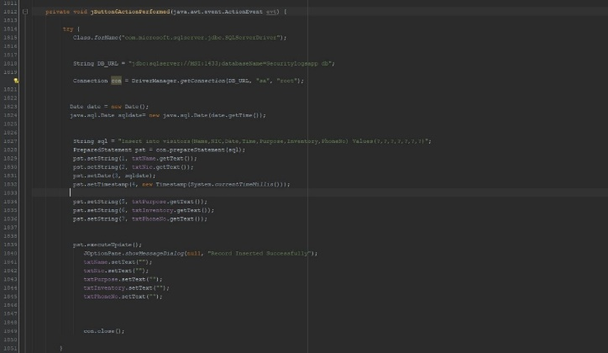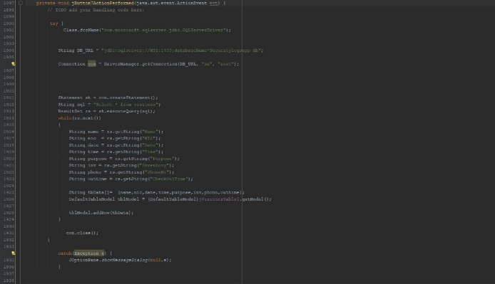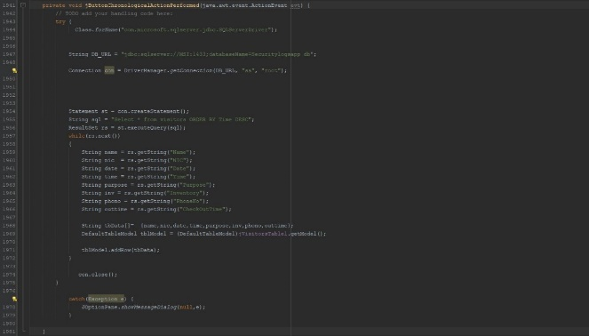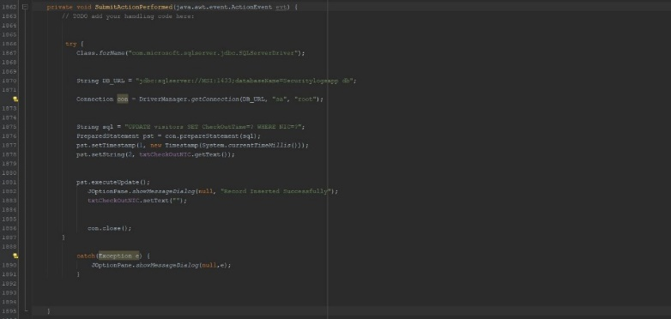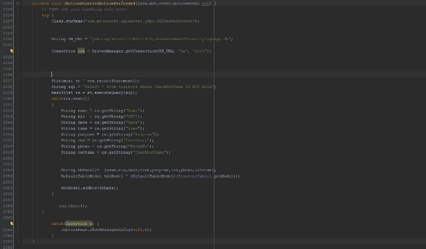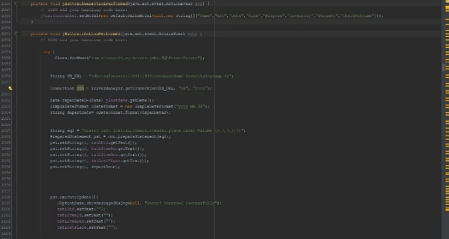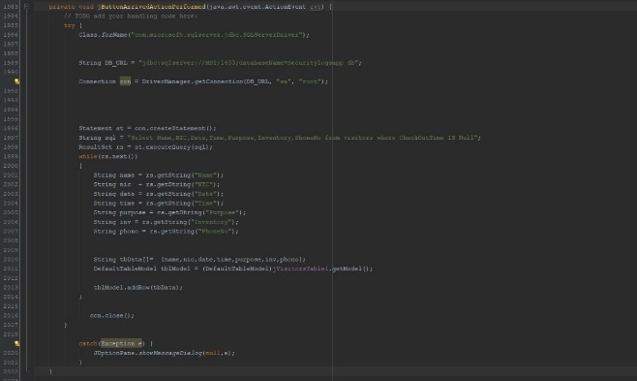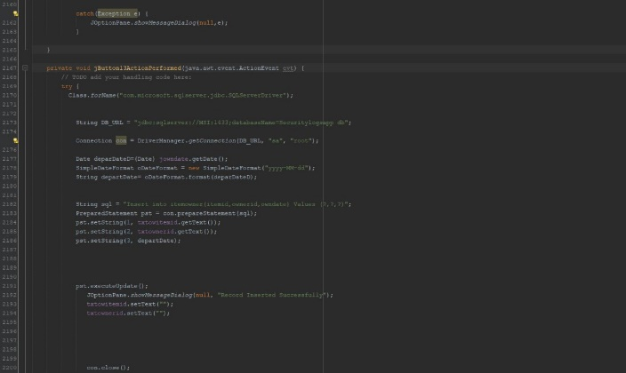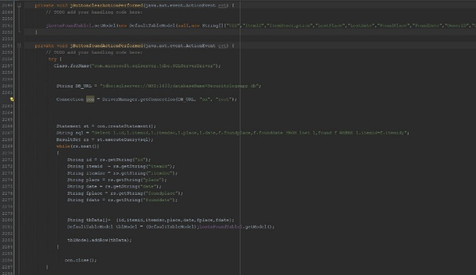

**Main Method**

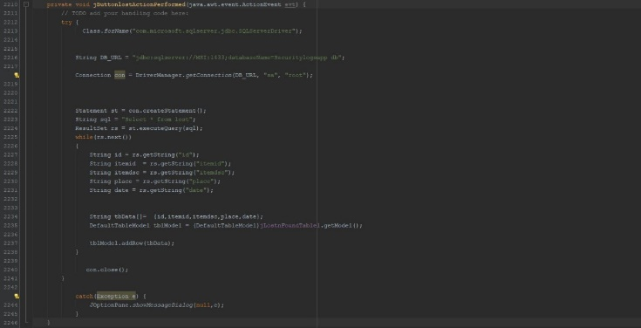

## GUI

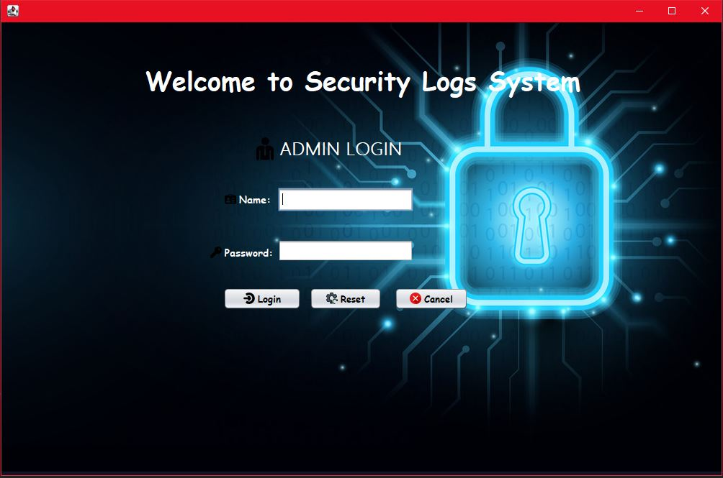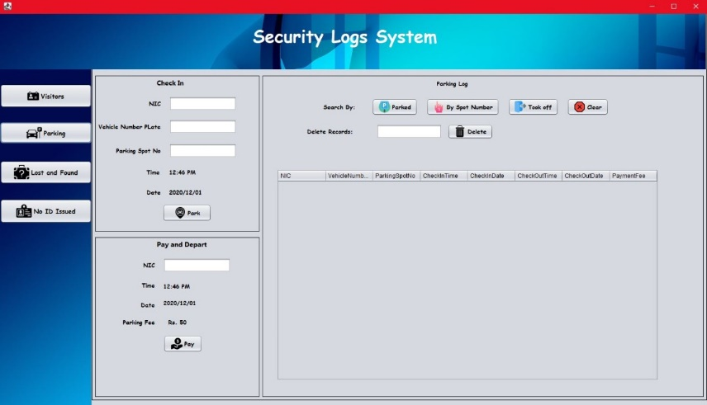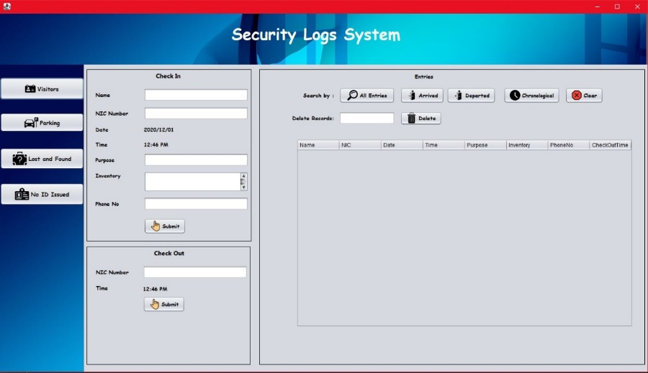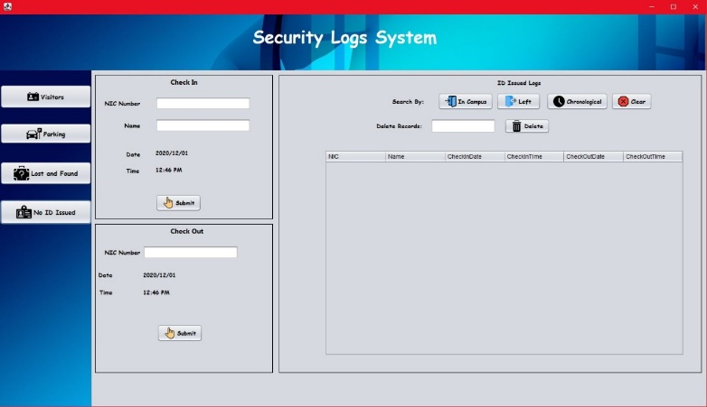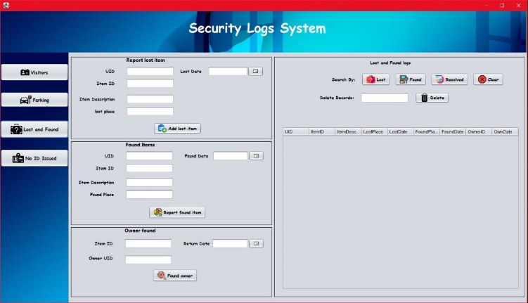

## Database

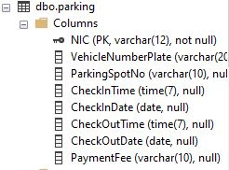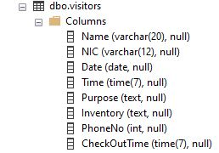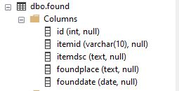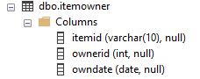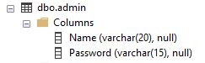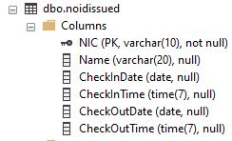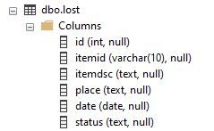

# Conclusion

The users are able to easily keep track of the records of the visitors, parking details, lost and found and people who visits the university without a ID card. Unlike the traditional system, they can filter records and sort records when they need. Users must be given credentials to login the system by a higher position.

Future Improvements,

* The software can be connected to the NSBM main database so that the relevant student and staff information can be viewed through our system.
* Include and alert system for lost and found section to notify people about lost and found items.
* Include a card payment integration for the parking section.